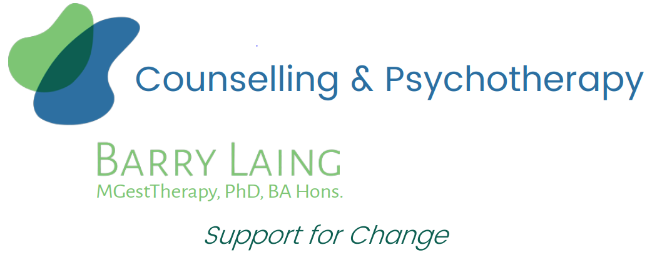 | Mob: 0422 922 485  Email: barrylaing@counsellingfootscray.com.au  Web: www.counsellingfootscray.com.au
Client Intake and Consent Form for Services Provided by Barry Laing
Name: | Date of Birth:
Address: | Reason for appointment:
Mob:

Email:

Emergency Contact:
Name –
Mob –
Relationship –

Goals or aspirations for working with me as your counsellor/psychotherapist
Imagined/anticipated timeframe

Diagnosed medical or psychiatric conditions | No Yes Please list:
Medications | No Yes Please list:
Have you seen a counsellor or psychotherapist before? | No Yes
How did you hear about me? (Please highlight) | My website? Word of mouth? Referral? (please specify)  Other? (please specify)
Please see over for Consent details, and to sign and date.
Client Intake and Consent Form for Services Provided by Barry Laing (cont.)
Service
This service is provided by Barry Laing as a private practitioner. Barry Laing is a Certified Practising Counsellor member of the Psychotherapy and Counselling Federation Australia (PACFA) Reg. 26551 and works according to the PACFA Code of Ethics. https://www.pacfa.org.au/wp-content/uploads/2017/11/PACFA-Code-of-Ethics-2017.pdf
Purpose of collecting and holding information
As part of providing counselling/psychotherapy to you, collecting and recording relevant personal information is necessary. This information is an essential component in the provision of professional support. Client notes will document session content for the purposes of review and development of tailored support. All client notes will be stored securely and only accessible by Barry Laing via password.
Access to Client Information
Clients are entitled to access information kept on file, unless the relevant legislation provides otherwise, and/or there is serious risk to the mental health and life of an individual or compromise to another’s privacy. Barry Laing will assist in access to information as appropriate and wherever possible.
Confidentiality
All personal information gathered by Barry Laing during the provision of service will remain confidential and secure, except where:
- It is subpoenaed by a court, or
- Failure to disclose the information would place you or another person at serious and imminent risk, or
- Your prior approval has been obtained to
  - provide a written report to another professional or agency, e.g., a GP or a lawyer, or
  - discuss the material with another person, e.g., a parent, partner or employer, or
- If disclosure is otherwise required or authorised by law.
To comply with professional standards and professional development, Barry Laing is required to participate in ongoing professional supervision, where non-identifying client information may be discussed to ensure the best possible support and care.
Privacy
This practice uses email and SMS for confirmation of appointments and reminder purposes.
Cancellation Policy
If you need to cancel or reschedule a booked appointment, a minimum of 24 hours’ notice is required, unless exceptional circumstances occur. This allows for the reassignment of cancelled bookings to other clients who may be waiting for an appointment. A cancellation fee equivalent to the full appointment fee applies to missed bookings where 24 hours’ notice is not provided.
I, (print name clearly) , have read and understood the above Consent Form and the circumstances where confidentiality may not be maintained. I consent to these conditions for the service provided by Barry Laing.

Signature: Date:

